**TABLE OF CONTENTS**

|  |  |  |
| --- | --- | --- |
| **No.** | **Title** | **Page No.** |
| **1** | **Project Profile** |  |
|  | 1.1 Definition |  |
|  | 1.2 Scope |  |
|  | 1.3 Objective |  |
| **2** | **System Analysis And Specification** |  |
|  | 2.1 Existing System |  |
|  | 2.2 Limitation Of Existing System |  |
|  | 2.3 Feasibility Study |  |
|  | 2.4 Need Of New System |  |
|  | 2.5 Font End & Back End Tools |  |
| **3** | **System Requirement Specification** |  |
|  | 3.1 Proposed System And Advantage |  |
|  | 3.2 Development Strategy Model |  |
| **4** | **System Design** |  |
|  | 4.1 Data Flow Diagram |  |
|  | 4.2 E-R Diagram |  |
|  | 4.3 Class Diagram |  |
|  | 4.4 Use Case Diagram |  |
|  | 4.5 Sequence Diagram |  |
|  | 4.6 Activity Diagram |  |
|  | 4.7 Data Dictionary (Database) |  |
| **5** | **Screen Design** |  |
|  | 5.1 Input Screen |  |
|  | 5.2 Output Screen |  |
|  | 5.3 Report Design |  |
| **6** | **Coding** |  |
| **7** | **Testing (Manual Test Cases and Test Data)** |  |
|  | 7.1 Manual Testing |  |
|  | 7.2 Test Cases |  |
| **8** | **Enhancements** |  |
|  | 8.1 Advantage Of Your Project |  |
|  | 8.2 Limitation Of Your Project |  |
|  | 8.3 Feature Scope |  |
| **9** | **References** |  |

1

PROJECT PROFILE

* 1. **Project Definition**
  2. **Project Scope**
  3. **Project Objective**

|  |  |  |
| --- | --- | --- |
| Project Profile | | |
|  | **Enrollment No.** | 03052001105  03052001105  03052001102 |
|  | **Student Name** | Timbaliya Rahul  Mihir Vaddoriya  Manish Parmar |
|  | **Project Title** | **India_Tour** |
|  | **Project Type** | Web Application |
|  | **Tools & Technology** | HTML,CSS,  JAVA-SCRIPT  PYTHON-DJANGO,  MYSQL |
|  | **Front – End** | DJANGO HTML CSS  JAVA SCRIP |
|  | **Back – End** | MYSQL,SQLLITE |
|  | **Team Member** | 3 |

**1.1 Project Definition :-**

* India_Tour System is a web-based technology that manages tour package and customer to easily book and find information about place
* India_Tour system is a web-based system which help tourist to see available Package in company and book that package online to save time and money
* Administration can store the data of package . The System also keeps the user book info**.**
* This project uses Django and MYSQL,SQLite databases, and it has a module that is admin. All possible features such as validation, validation, security, etc., are considered.
* The proposed system influences or interacts with Tourist That can find any online service to book its package.
* This project also includes system testing and validation, which ensures that your System is error-free and working as expected.
  1. **Project Scope**

A . **Hardware Specification**

* Intel-core-i3/Intel-core-i5 and Higher Prosessor
* 512 Mb Ram
* 1 GB Free Hard-Drive Space

**A . Software Specification**

* PHP (Font-end)
* HTML
* JavaScript
* MS Word 97 or later
* Visual Studio Code
* Web Browser: Microsoft Internet Explorer, Mozilla, Google Chrome or later
* MySQL Server (back-end)
* Operating System: Windows 10 / Windows 7/ Windows XP

* 1. **Project Objective**

A . **Hardware Specification**

* Intel-core-i3/Intel-core-i5 and Higher Prosessor
* 512 Mb Ram
* 1 GB Free Hard-Drive Space

**A . Software Specification**

* PHP (Font-end)
* HTML
* JavaScript
* MS Word 97 or later
* Visual Studio Code
* Web Browser: Microsoft Internet Explorer, Mozilla, Google Chrome or later
* MySQL Server (back-end)
* Operating System: Windows 10 / Windows 7/ Windows XP

2

System AnaLYSis And Speciffication

* 1. **Existing System**
  2. **Limitations Of Existing System**
  3. **Feasibility Study**
  4. **Need Of New System**
  5. **Font End & Back End Tool**
  6. **Existing System**
  7. **Limitation Of Existing System**
  8. **Feasibility Study**
* After implementing the Zoo Management System project and investigating and analyzing all existing or required features of the System, the next task is to carry out a feasibility study. All projects can be run with unlimited resources and infinite time, and the feasibility study involves considering all possible ways to provide a solution to a given problem. The proposed solution should meet all user requirements and be flexible enough to adapt to future changes based on future needs quickly.

### Economic Feasibility

* This is an essential aspect to consider when developing a project. We chose the technology based on the lowest possible cost factors.
* The organization must bear all hardware and software costs.
* Overall, it is estimated that the benefits that an organization will get from the proposed System will outweigh the initial and subsequent costs

### Technical Feasibility

* This included investigating features, performance, and limitations that could affect the ability to achieve a tolerable system. To demonstrate this proof of concept, we have explored all the features provided by the System as described in the System. Requirements Specification (SRS), and everything is possible with the different types of front-end and backend platforms. I confirmed that there is.
* Operational feasibility Undoubtedly, the proposed System is completely GUI-based, very user-friendly, and all inputs are self-explanatory to the layman. In addition, proper training is provided to convey the essence of the System to the user, and the user can become accustomed to the new System. Our customers are comfortable and happy with our research because the System has reduced stress and strain.
  1. **Need Of New System**
  2. **Font End & Back End Tool**
* **Front End Tools**
* **HTML**



* The **HyperText Markup Language** or **HTML** is the standard [markup language](https://en.wikipedia.org/wiki/Markup_language) for documents designed to be displayed in a [web browser](https://en.wikipedia.org/wiki/Web_browser).
* HTML (Hypertext Markup Language) is the only markup language for creating web pages. It provides some titles, headings, paragraphs, lists, tables, embedded images, etc., to describe the structure of text-based and multimedia information in HTML documents.
* HTML is a [markup language](https://en.wikipedia.org/wiki/Markup_language) that [web browsers](https://en.wikipedia.org/wiki/Web_browser) use to interpret and [compose](https://en.wikipedia.org/wiki/Typesetting) text, images, and other material into visual or audible web pages
* HTML is a [markup language](https://en.wikipedia.org/wiki/Markup_language) that [web browsers](https://en.wikipedia.org/wiki/Web_browser) use to interpret and [compose](https://en.wikipedia.org/wiki/Typesetting) text, images, and other material into visual or audible web pages.
* The First Version Of HTMLWas Written BY **Tim-Burners-Lee**
* **October 28, 2014** HTML5 was published as a W3C Recommendation
* **CSS**



* **Cascading Style Sheets** (**CSS**) is a [style sheet language](https://en.wikipedia.org/wiki/Style_sheet_language) used for describing the [presentation](https://en.wikipedia.org/wiki/Presentation_semantics) of a document written in a [markup language](https://en.wikipedia.org/wiki/Markup_language) such as [HTML](https://en.wikipedia.org/wiki/HTML) or [XML](https://en.wikipedia.org/wiki/XML) (including XML dialects such as [SVG](https://en.wikipedia.org/wiki/Scalable_Vector_Graphics), [MathML](https://en.wikipedia.org/wiki/MathML) or [XHTML](https://en.wikipedia.org/wiki/XHTML)) CSS is a cornerstone technology of the [World Wide Web](https://en.wikipedia.org/wiki/World_Wide_Web), alongside HTML and [JavaScript](https://en.wikipedia.org/wiki/JavaScript).
* CSS is said to as the cornerstone design tool of the World Wide Web along with HTML and JavaScript
* CSS level 1, published on 17 December 1996. [Håkon Wium Lie](https://en.wikipedia.org/wiki/H%C3%A5kon_Wium_Lie) and [Bert Bos](https://en.wikipedia.org/wiki/Bert_Bos) are credited as the original developers
* **Java-Script**



* JavaScript  often abbreviated to JS, is a [programming language](https://en.wikipedia.org/wiki/Programming_language) that is one of the core technologies of the [World Wide Web](https://en.wikipedia.org/wiki/World_Wide_Web), alongside [HTML](https://en.wikipedia.org/wiki/HTML) and [CSS](https://en.wikipedia.org/wiki/CSS).As of 2022, 98% of [websites](https://en.wikipedia.org/wiki/Website) use JavaScript on the [client](https://en.wikipedia.org/wiki/Client_(computing)) side for [webpage](https://en.wikipedia.org/wiki/Web_page) behavior, often incorporating third-party [libraries](https://en.wikipedia.org/wiki/Library_(computing)).[All major [web browsers](https://en.wikipedia.org/wiki/Web_browser) have a dedicated [JavaScript engine](https://en.wikipedia.org/wiki/JavaScript_engine) to execute the [code](https://en.wikipedia.org/wiki/Source_code) on [users](https://en.wikipedia.org/wiki/User_(computing))' devices..
* JavaScript Was Invented By Brendan Eich in 1995
* It Was Developed For Netscape 2, became the ECMA-262 Standard in 1997
* **Back End Tools**
* **Python-Django**



**What is Django?**

* Django is a Python-based web framework which allows you to quickly create web application without all of the installation or dependency problems that you normally will find with other frameworks.
* When you’re building a website, you always need a similar set of components: a way to handle user authentication (signing up, signing in, signing out), a management panel for your website, forms, a way to upload files, etc. Django gives you ready-made components to use**.**

**Why Django?**

* It’s very easy to switch database in Django framework

.

* It has built-in admin interface which makes easy to work with it.
* Django is fully functional framework that requires nothing else.
* It has thousands of additional packages available.
* It is very scalable**.**

**Features of Django**

Versatility of Django

* Django can build almost any type of website. It can also work with any client-side framework and can deliver content in any format such as HTML, JSON, XML etc. Some sites which can be built using Django are wikis, social networks, new sites etc.

Security

* Since Django framework is made for making web development easy, it has been engineered in such a way that it automatically do the right things to protect the website. For example, In the Django framework instead of putting a password in cookies, the hashed password is stored in it so that it can’t be fetched easily by hackers.

Scalability

* Django web nodes have no stored state, they scale horizontally – just fire up more of them when you need them. Being able to do this is the essence of good scalability. Instagram and Disqus are two Django based products that have millions of active users, this is taken as an example of the scalability of Django.

Portability

* All the codes of the Django framework are written in Python, which runs on many platforms. Which leads to run Django too in many platforms such as Linux, Windows and Mac OS.
* **Mysql (Database)**



* MySQL is currently the most popular database management system software used for managing the relational database. It is open-source database software, which is supported by Oracle Company. It is fast, scalable, and easy to use database management system in comparison with Microsoft SQL Server and Oracle Database. It is commonly used in conjunction with [PHP](https://www.javatpoint.com/php-tutorial) And Other scripts for creating powerful and dynamic server-side or web-based enterprise applications.
* It is developed, marketed, and supported by MySQL AB, a Swedish company, and written in [C programming language](https://www.javatpoint.com/c-programming-language-tutorial) and [C++ programming language](https://www.javatpoint.com/cpp-tutorial). The official pronunciation of MySQL is not the My Sequel; it is My Ess Que Ell. However, you can pronounce it in your way. Many small and big comanies use MySQL. MySQL supports many Operating Systems like [Windows](https://www.javatpoint.com/windows), [Linux](https://www.javatpoint.com/linux-tutorial), MacOS, etc. with C, C++, and [Java languages](https://www.javatpoint.com/java-tutorial).
* **Sqlite (Database)**



* SQLite is an in-process library that implements a self-contained, serverless, zero-configuration, transactional SQL database engine. It is a popular choice as an embedded database for local/client storage in application software such as web browsers. It is also used in many other applications that need a lightweight, embedded database.
* SQLite is ACID-compliant and implements most of the SQL standards, using a dynamically and weakly typed SQL syntax that does not guarantee domain integrity.
* To use SQLite in a C/C++ program, you can use the sqlite3 API, which provides a lightweight, simple, self-contained, high-reliability, full-featured, and SQL database engine. The API is implemented as a library of C functions that can be called from your program. One of the main benefits of using SQLite is that it is very easy to get started with. To create a new database in SQLite, you simply need to create a new file on your filesystem and connect to it using the sqlite3 API. For example, in C:

3

System Requirement Specification

**3.1 Proposed System And Advantage**

**3.2 Development Strategy Model**

* 1. **Proposed System And Advantage**

* In The Technological Word all The Work Is Done By The Web That’s Not Any Existing System Is Providing This Type Services To User Interact With The Zoo .
* The System was Outdated For The User It’s need To Upgrade Frequently
* Many facilities Is Not Providing On The Existing System .
* At The Time Of Any Occasion Heavy Traffic On The Zoo Counter And Staff User Will Not Manage It
* Not Providing Any Online Booking Services To User Book The Ticket.
* Some Time Data Error is occur In The Database

**Advantages**

* Not Providing Online Service
* Online Booking Is Not Providing
* Not Handle Heavy Load
* Not User-Friendly
* UI Is Older
* Some Changes On The Requirements
* Some Time Crashed

**3.2 Development Strategy Model**

4

System DESIGN

**4.1 Data Flow Diagram**

**4.2 E-R Diagram**

**4.3 Class Diagram**

**4.4 Use Case Diagram**

**4.5 Sequence Diagram**

**4.6 Activity Diagram**

**4.7 Data Dictionary(Database)**

**4.1 Data Flow Diagram**

* **User Module DFD**

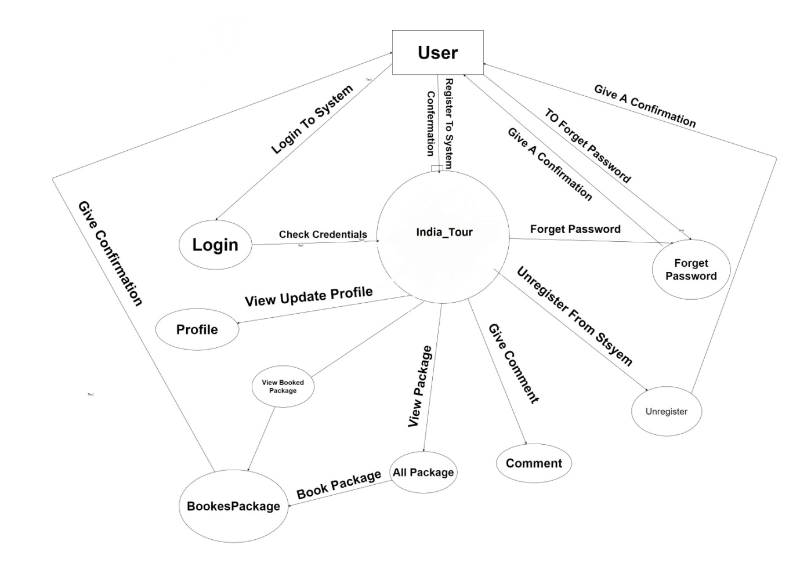

* **Admin Module DFD**

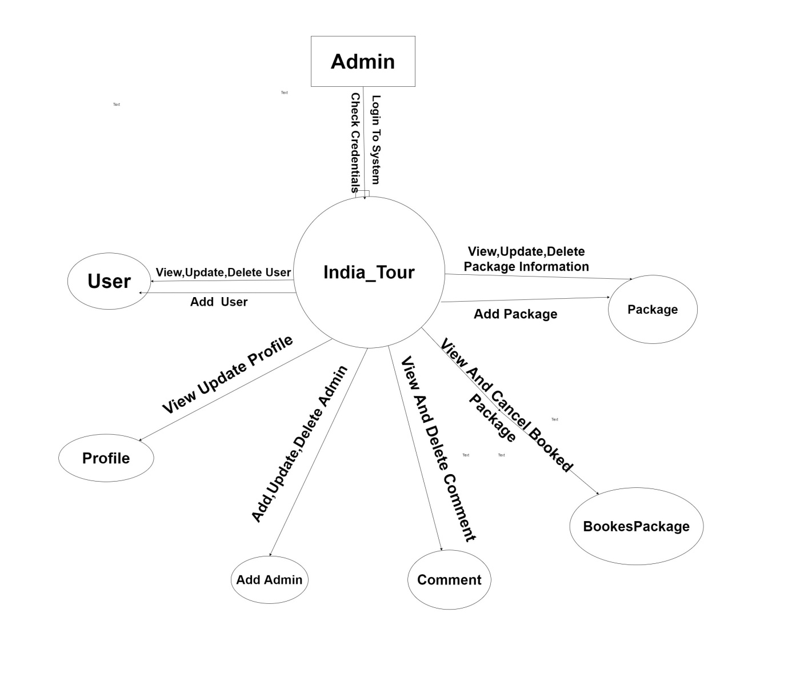

**4.2 E-R Diagram:**

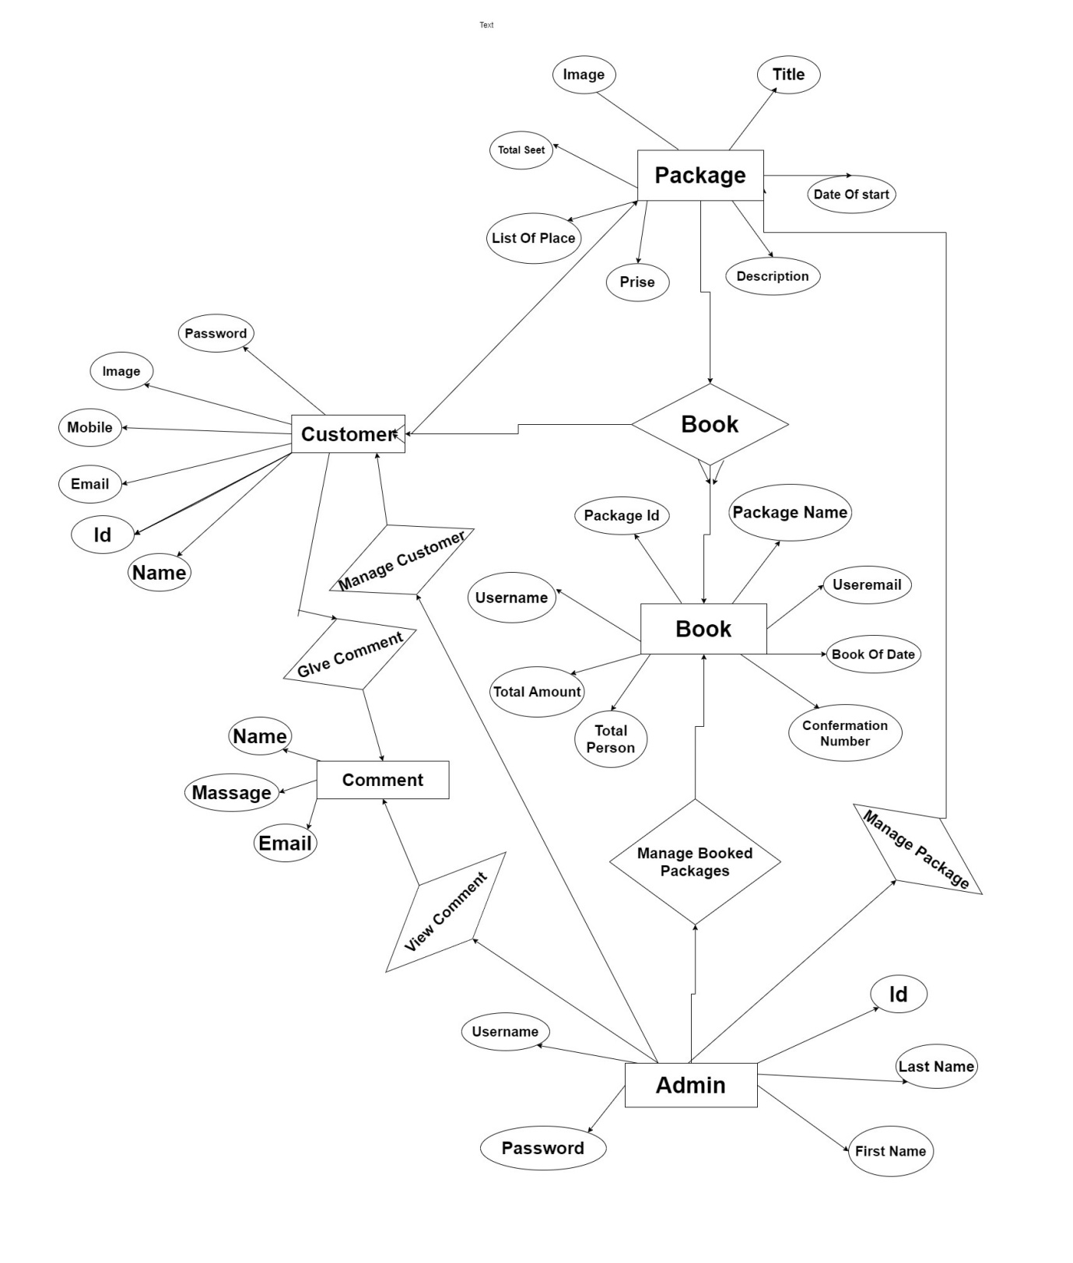

**4.3 Class Diagram**

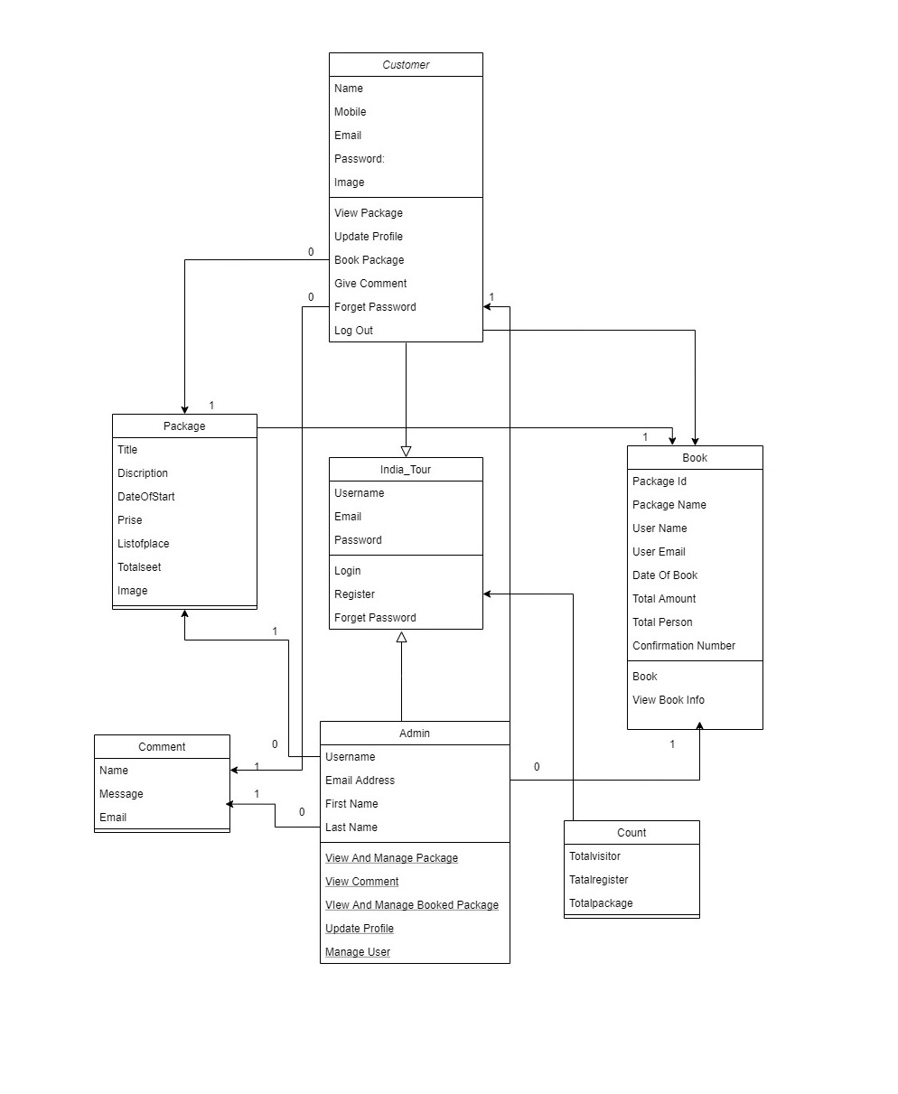

**4.4 Use Case Diagram**

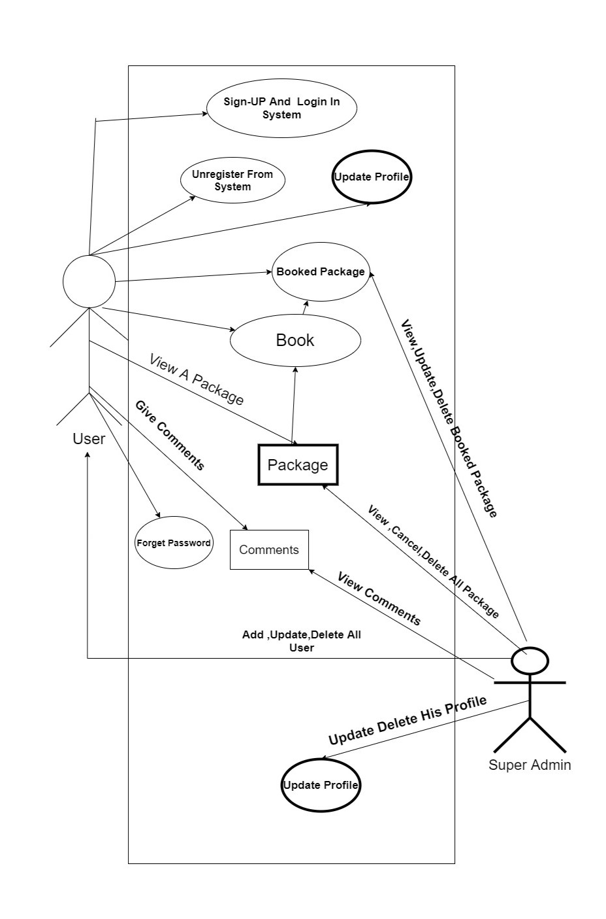

**4.5 Sequence Diagram**

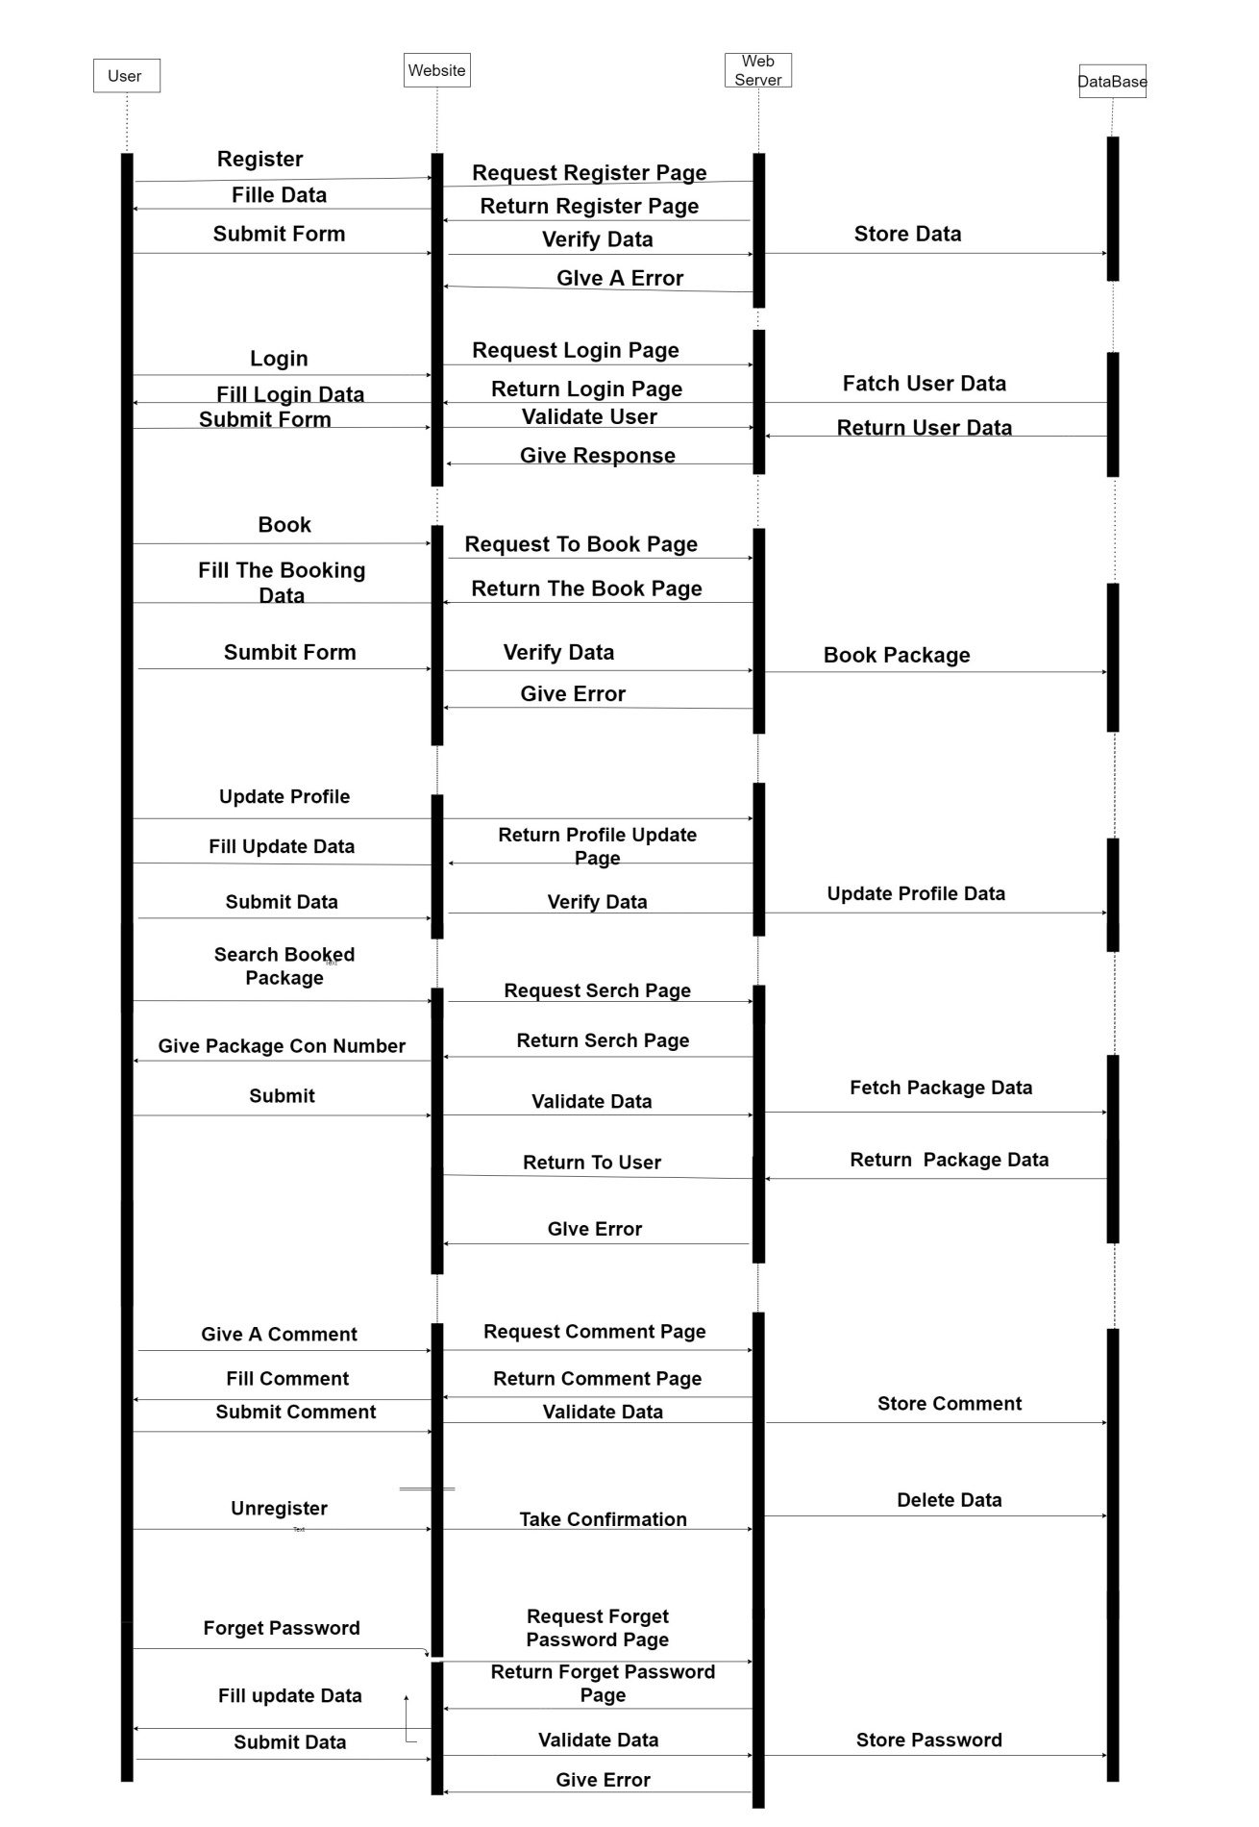

**4.6 Activity Diagram**

* **User Activity Diagram**

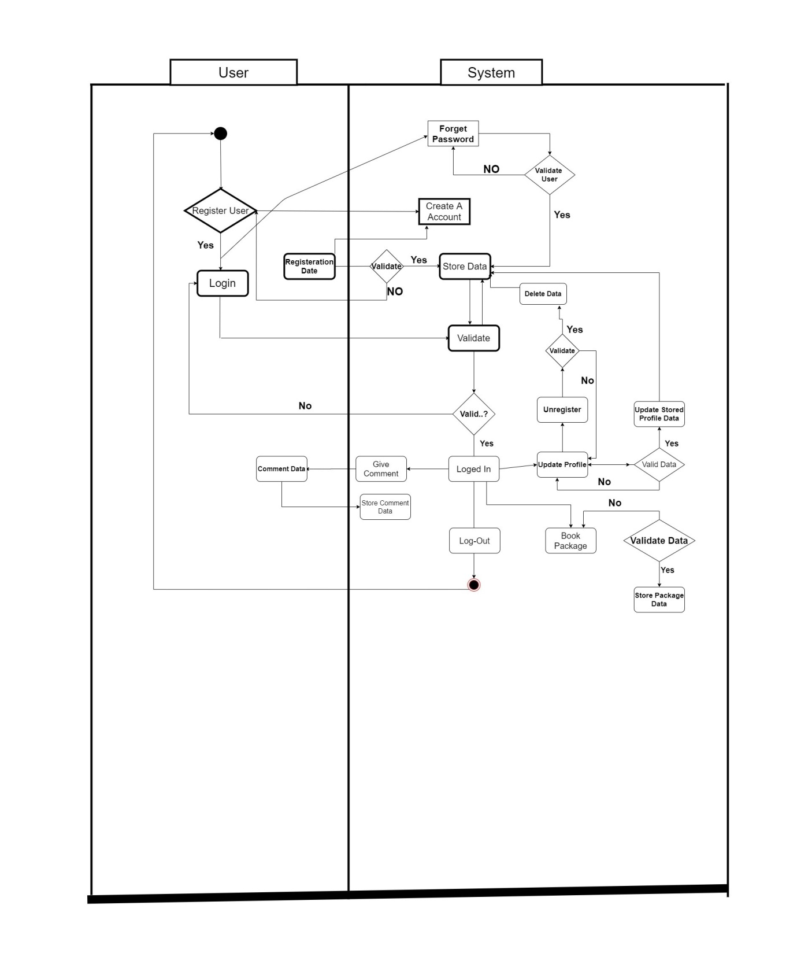

* **Admin Activity Diagram**

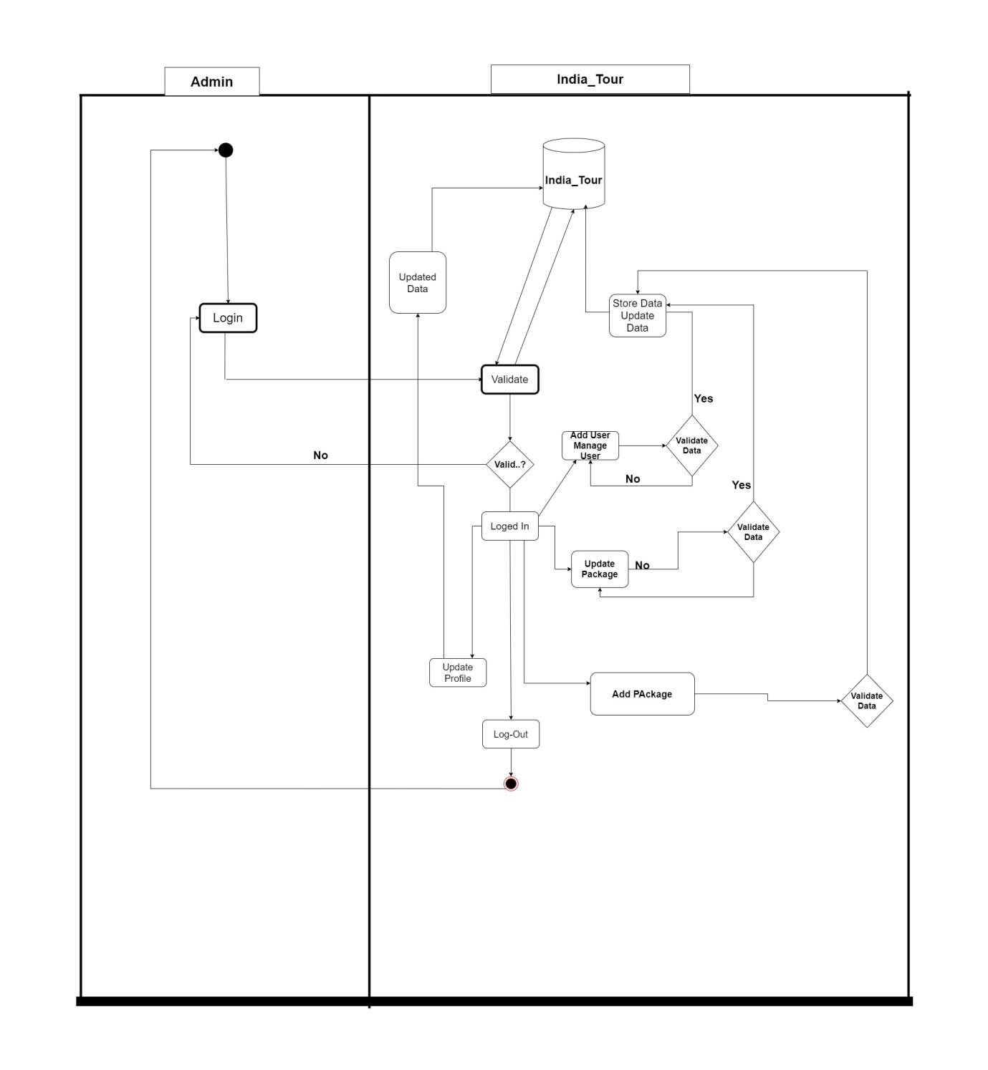

**4.7 Data Dictionary (Database)**

* **Customer:**

|  |  |  |  |
| --- | --- | --- | --- |
| No | Name | Type | Constrain |
| 1 | ID | Integer(100) | Not Null  Auto Increment |
| 2 | Name | Varchar(255) | - |
| 3 | Email | Varchar(225) | - |
| 4 | Mobile | Varchar(225) | - |
| 5 | Image | Varchar(255) | - |

* **Users:**

|  |  |  |  |
| --- | --- | --- | --- |
| No | Name | Type | Constrain |
| 1 | ID | Integer(50) | Not Null  Auto Increment |
| 2 | Username | Varchar (225) | - |
| 3 | Password | Varchar(255) | - |
| 4 | Email Address | Varchar(225) | - |
| 5 | First Name | Varchar(225) | - |
| 6 | Last Name | Varchar(20) | - |

* **Contact :**

|  |  |  |  |
| --- | --- | --- | --- |
| No | Name | Type | Constrain |
| 1 | Full Name | Varchar(50) | - |
| 2 | Email | Varchar(50) | - |
| 3 | Massage | Varchar(350) |  |

* **Package:**

|  |  |  |  |
| --- | --- | --- | --- |
| No | Name | Type | Not null |
| 1 | Id | Integer(255) | Not Null  Auto increment |
| 2 | Title | Varchar(255) | - |
| 3 | Description | Varchar (225) | - |
| 4 | Date Of Start | Varchar(255) | - |
| 5 | Prise | Varchar(255) |  |
| 6 | List Of Place | Varchar(255) | - |
| 7 | Total Seet | Varchar(225) |  |
| 8 | Image | Image(225) |  |

* **Book :**

|  |  |  |  |
| --- | --- | --- | --- |
| No | Name | Type | Constrain |
| 1 | Id | Integer (100) | Not Null  Auto Increment |
| 2 | PackageId | Varchar(225) | - |
| 3 | Package Name | Varchar(225) | - |
| 4 | User Name | Varchar (225) | - |
| 5 | User Email | Varchar (225) | - |
| 6 | Date Of Book | Date | - |
| 7 | Total Amount | Varchar (225) | - |
| 8 | Total Person | Varchar(225) | - |
| 9 | Confirmation Number | Varchar (225) | - |

* **Count:**

|  |  |  |  |
| --- | --- | --- | --- |
| No | Name | Type | Constrain |
| 1 | ID | Integer  (50) | Not Null  Auto Increment |
| 2 | Total Visitor | Varchar(225) | - |
| 3 | Total Regiaster | Varchar(225) | - |
| 4 | Total Package | Varchar(225) | - |

5

**Screen Design**

**5.1 Input Screen**

**5.2 Output Screen**

**5.3 Sample Code**

**5.1 Input Screen**

* **SignUp Page.**

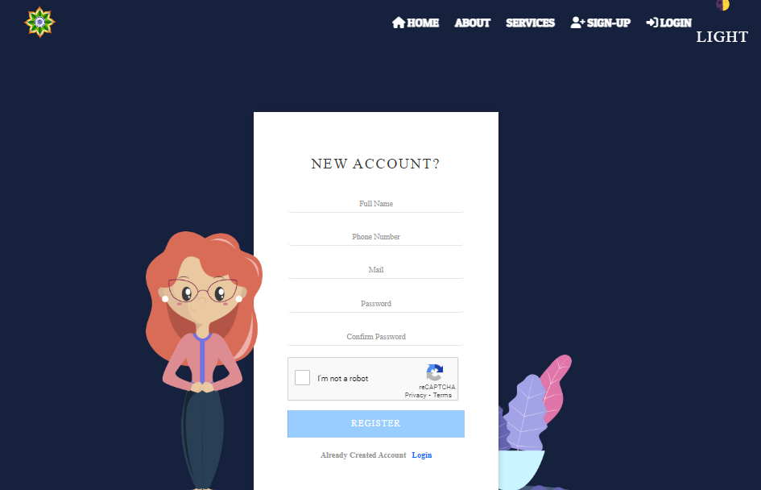

* **Login Page:**

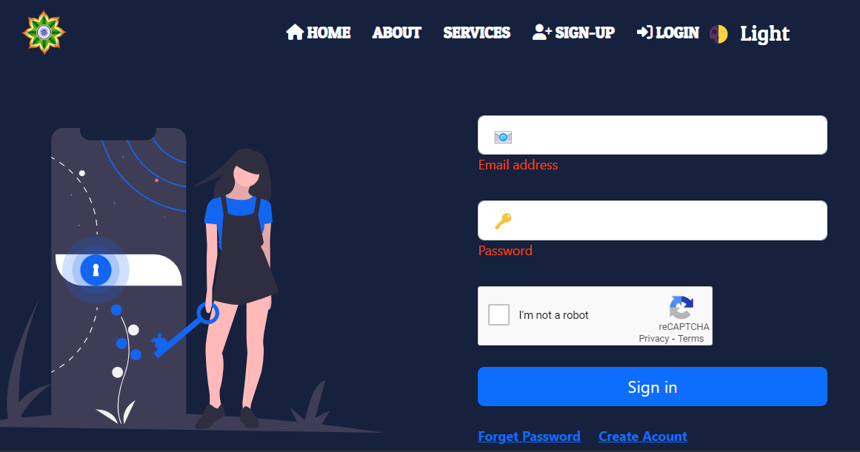

* **Forget Password Page:**

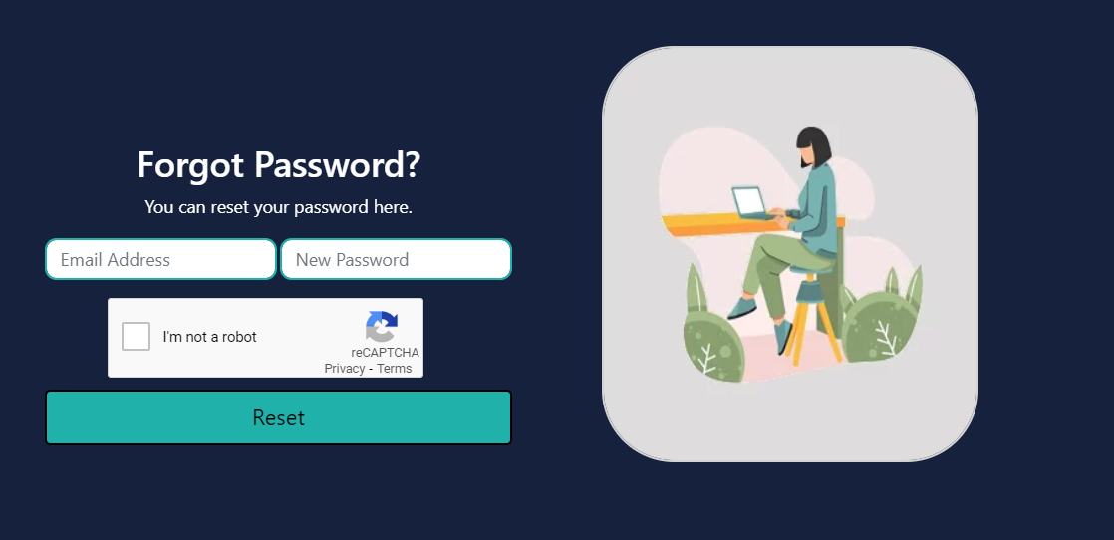

## Email Otp Page:

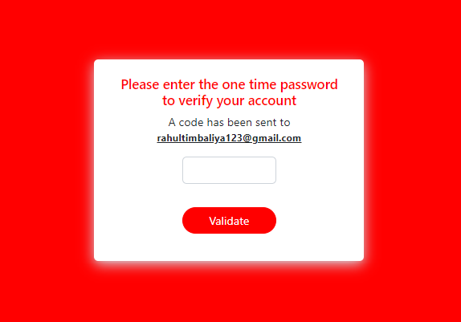

## Book Page:

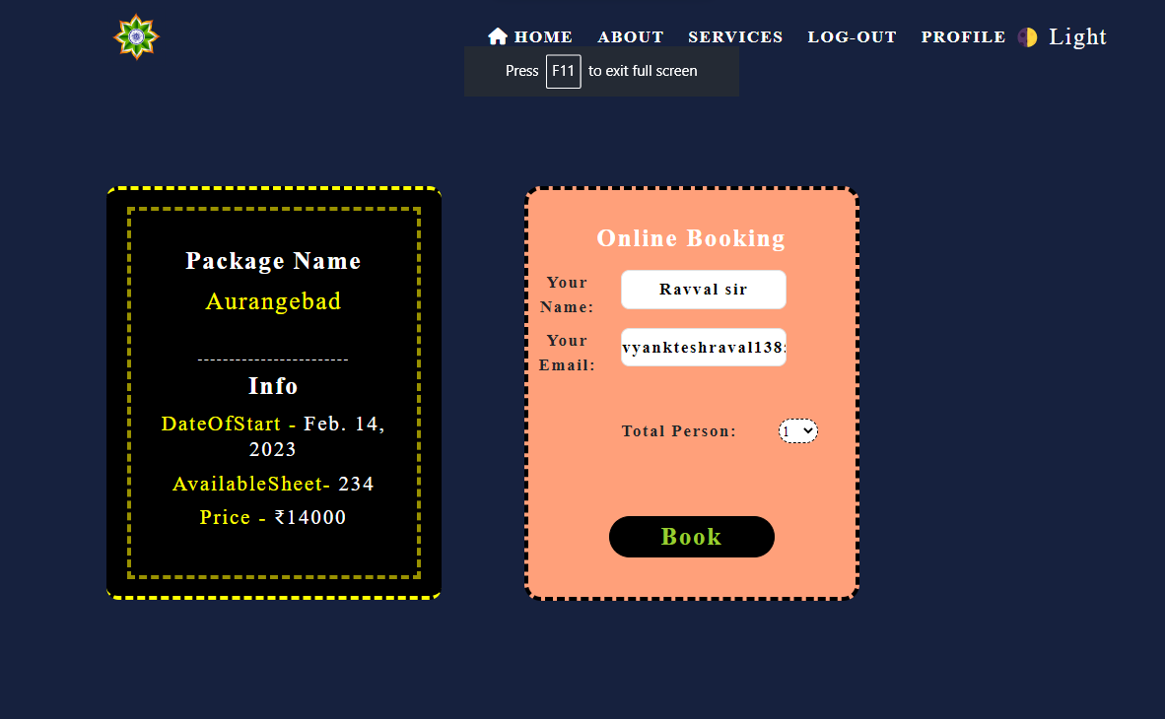

* + - **Profile Page:**

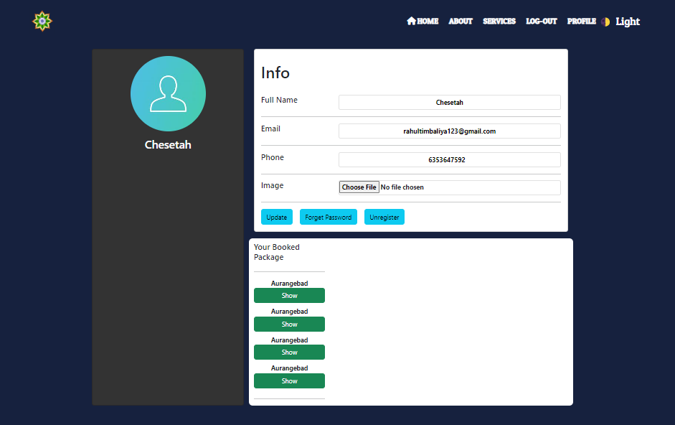

* + - **Contact Page:**

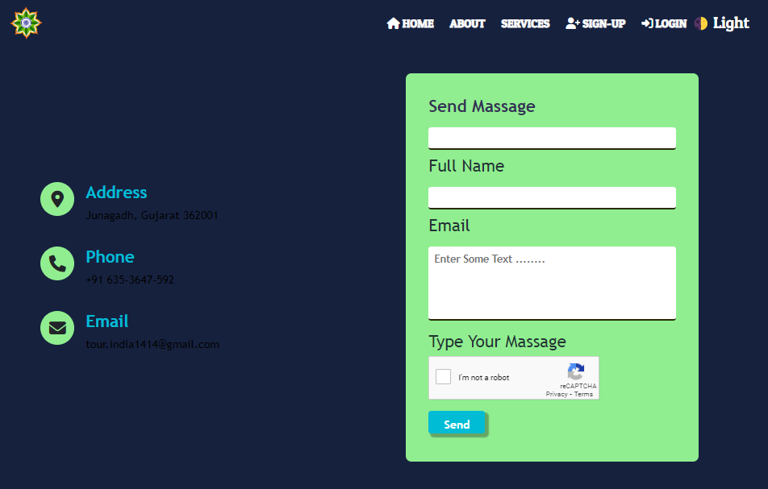

## Admin Login:

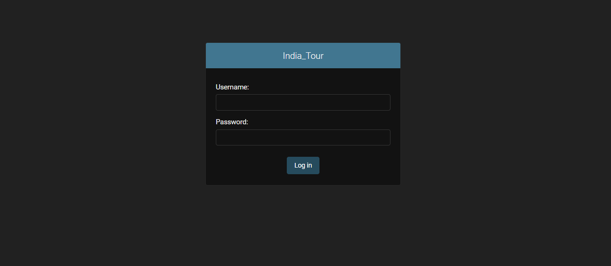

**5.1 Output Screen**

## IndexPage:

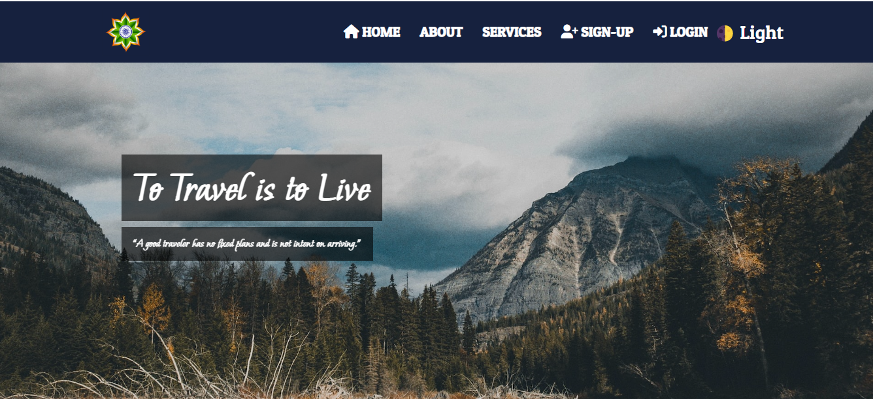

## Admin Dashboard:

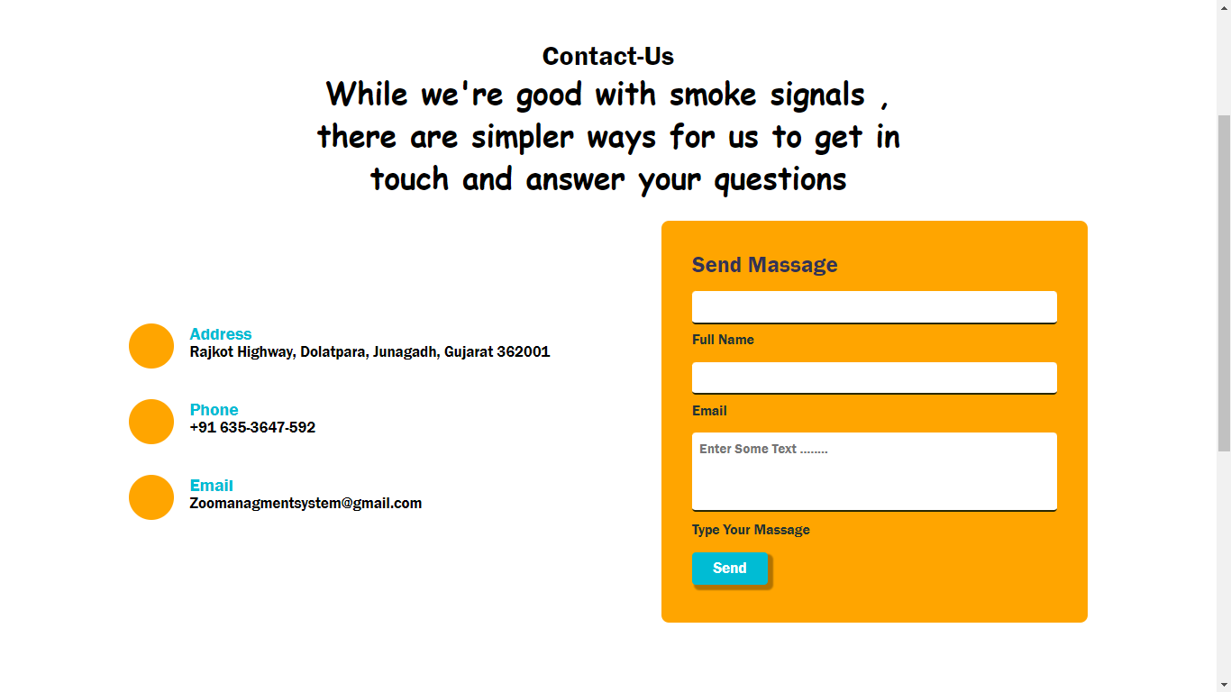

## User-Forgot Password:

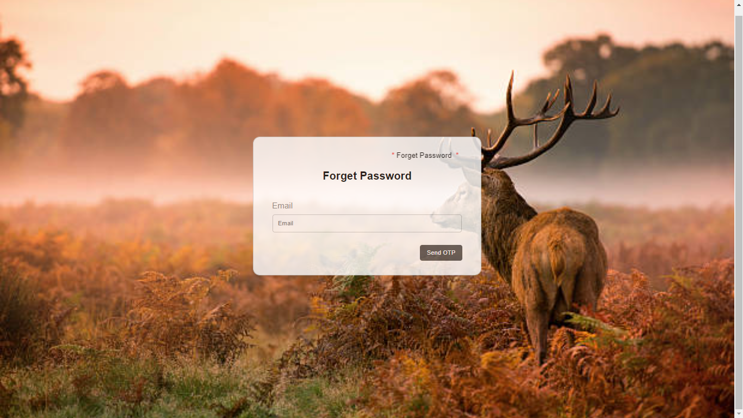

## User-Profile Page:

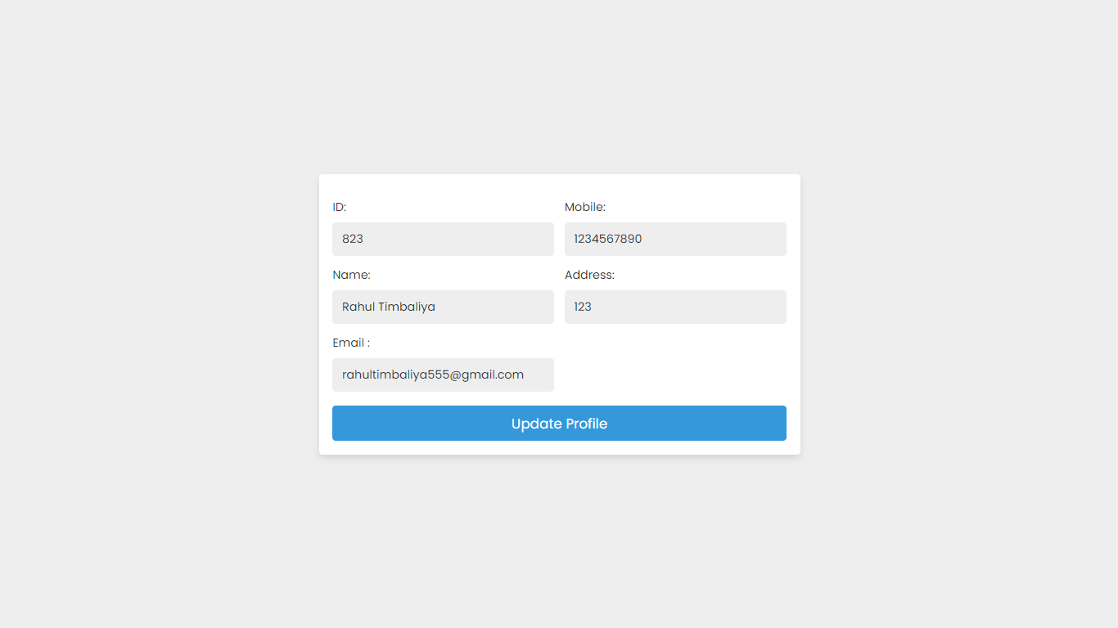

## S

## Staff-User-Page 1:

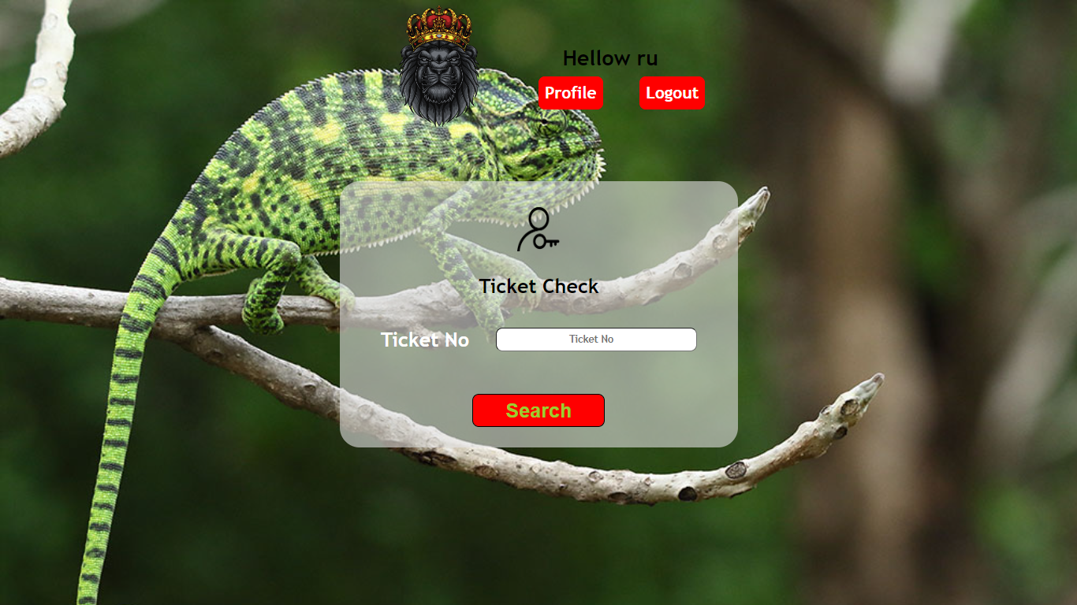

## Staff-User-Page 2:

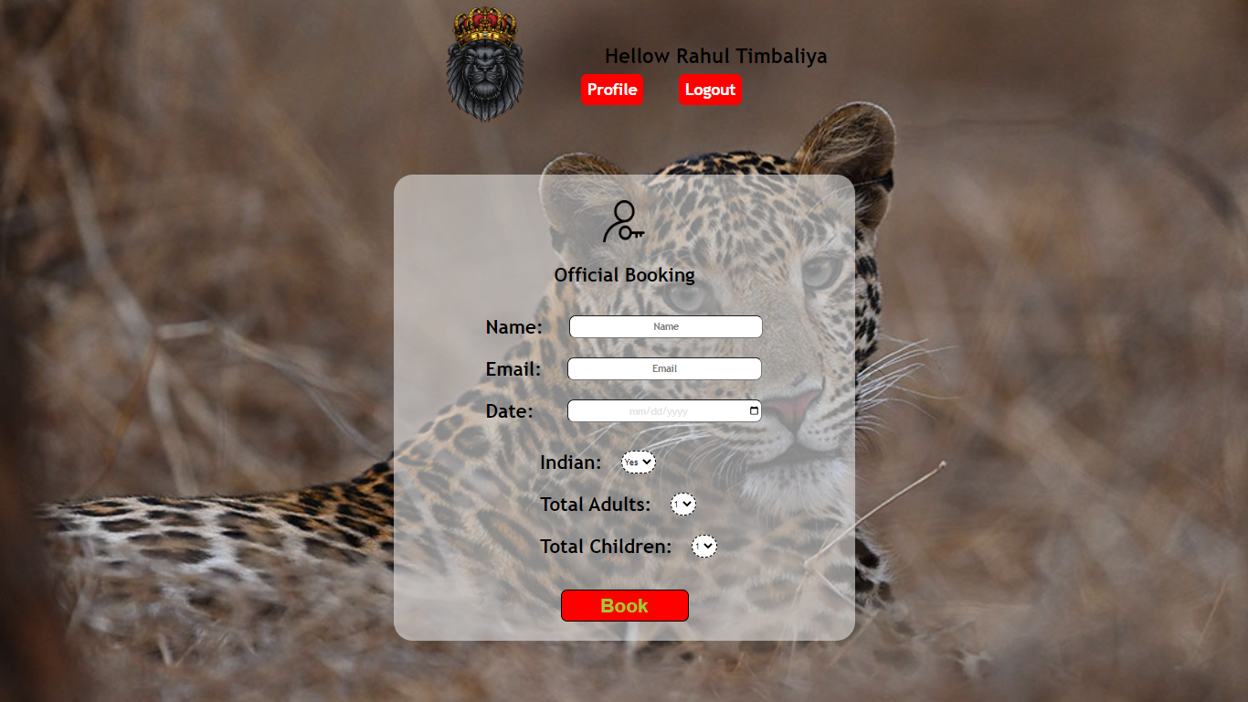

## Staff-User Profile:

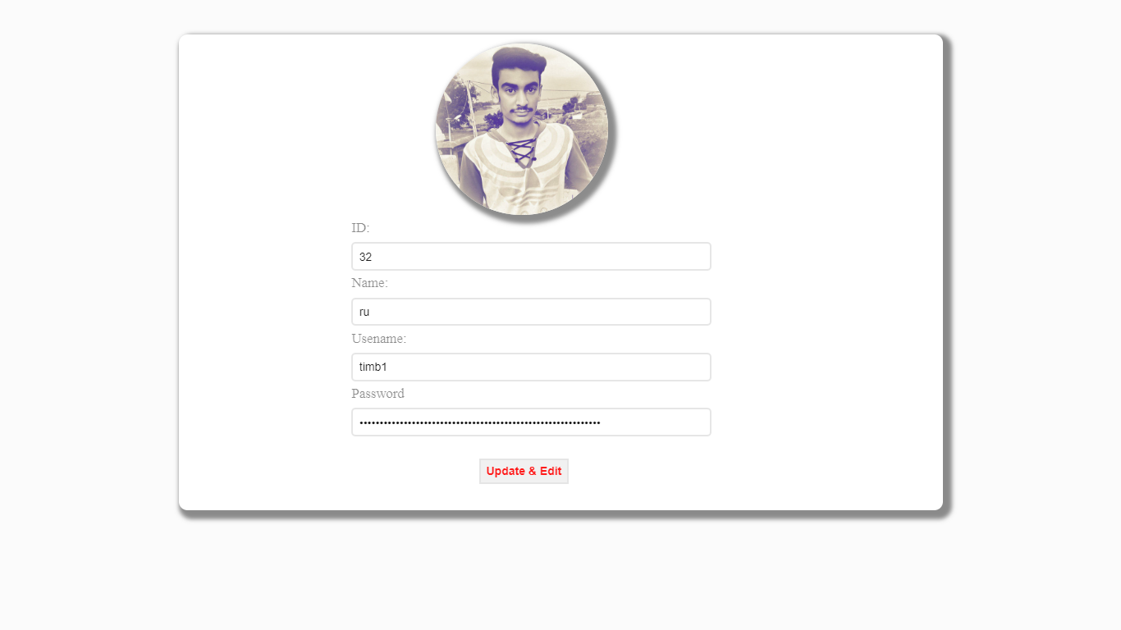

## Developer Info Page:

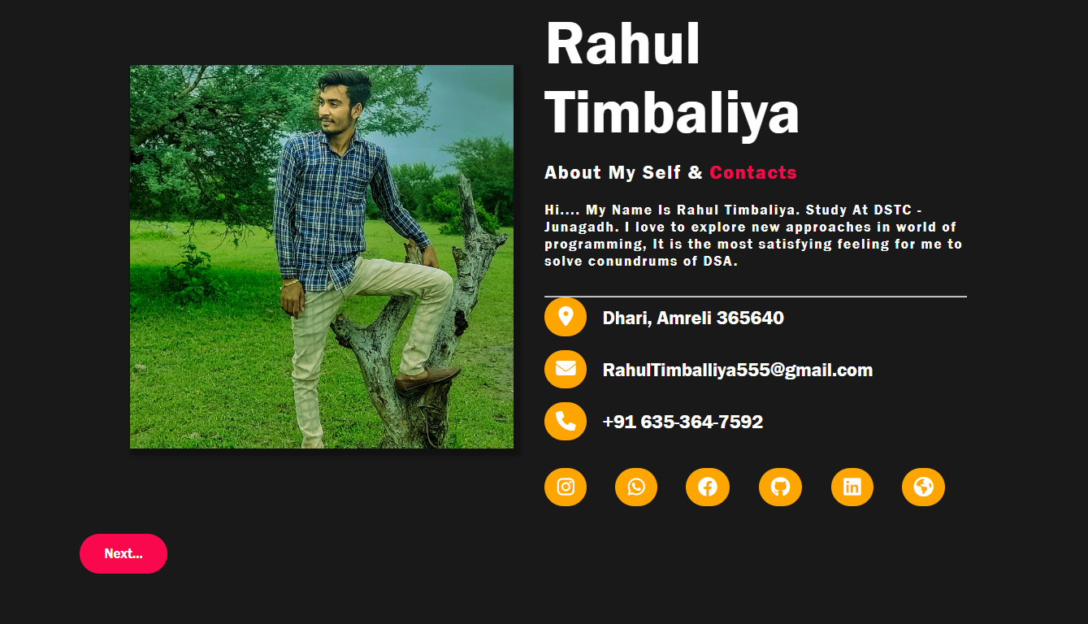

## Admin Section:

## Admin-Profile:

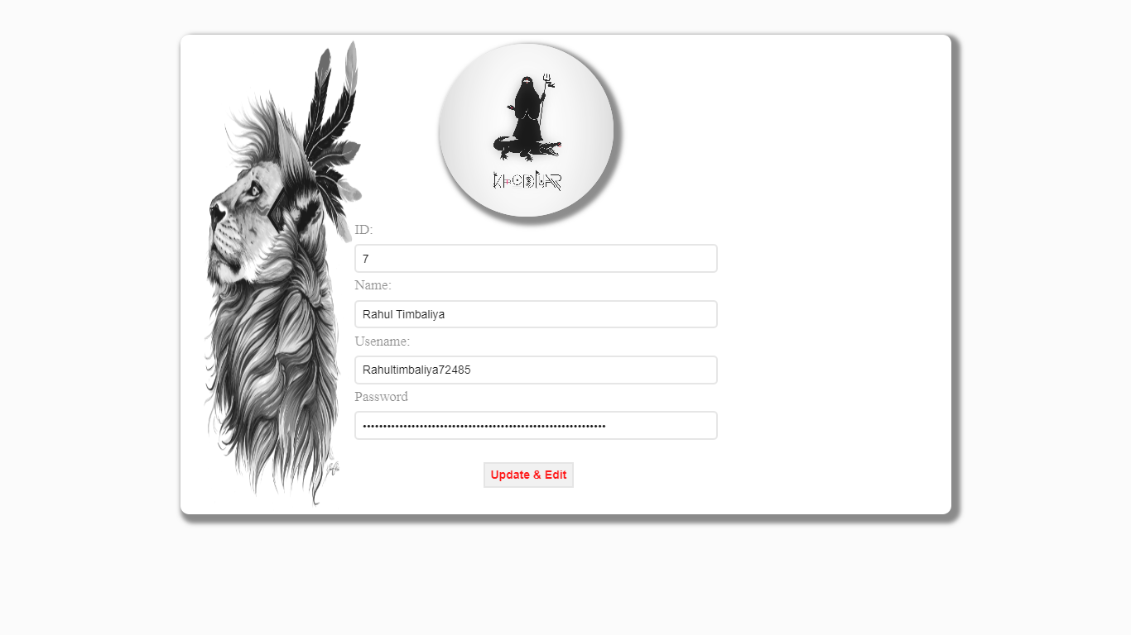

## View Ticket:

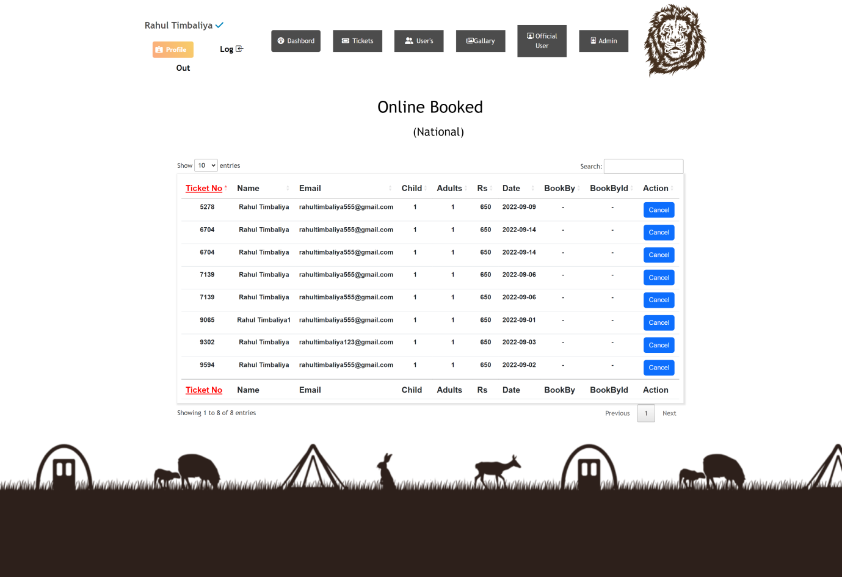

## Edit-Price:

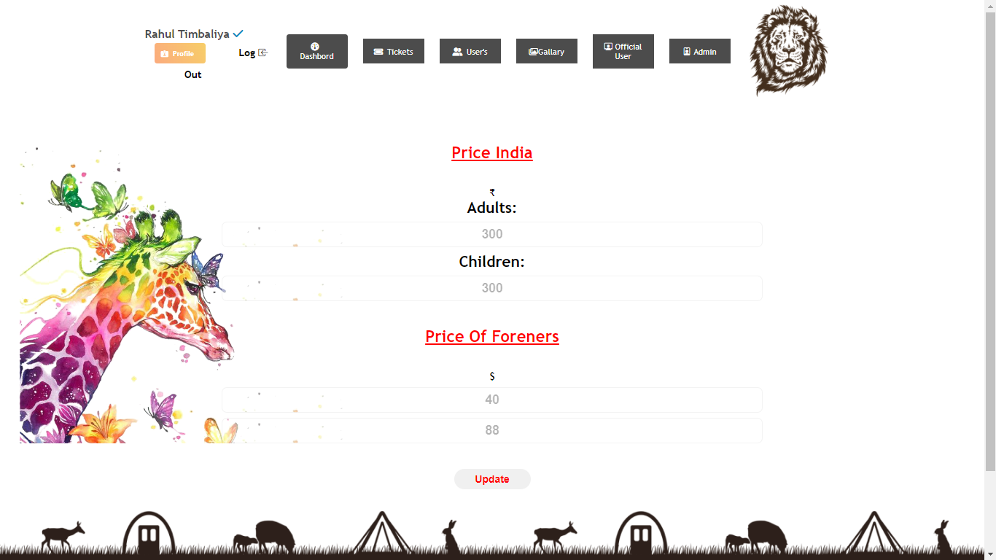

* Add-User:

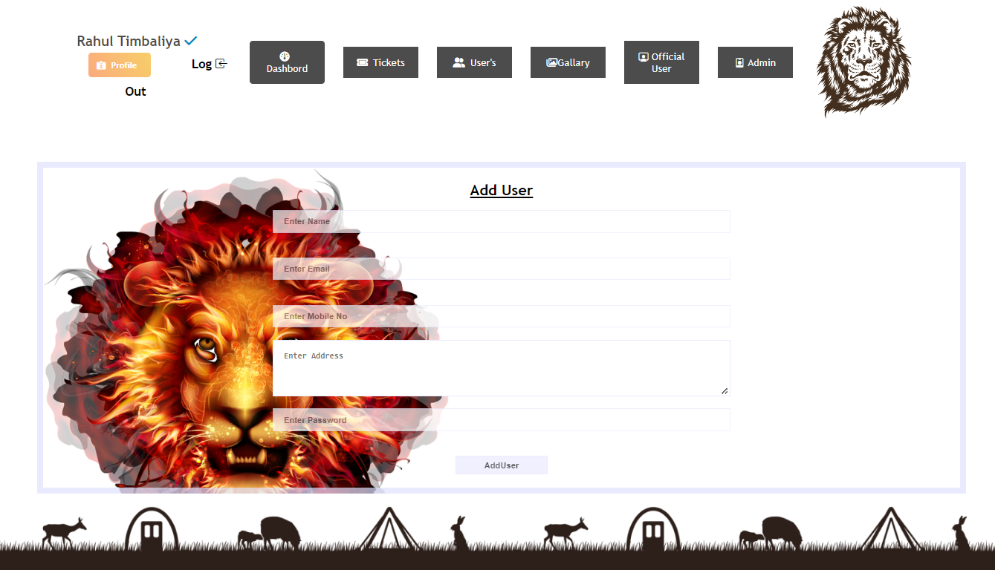

* View-Registerd User:

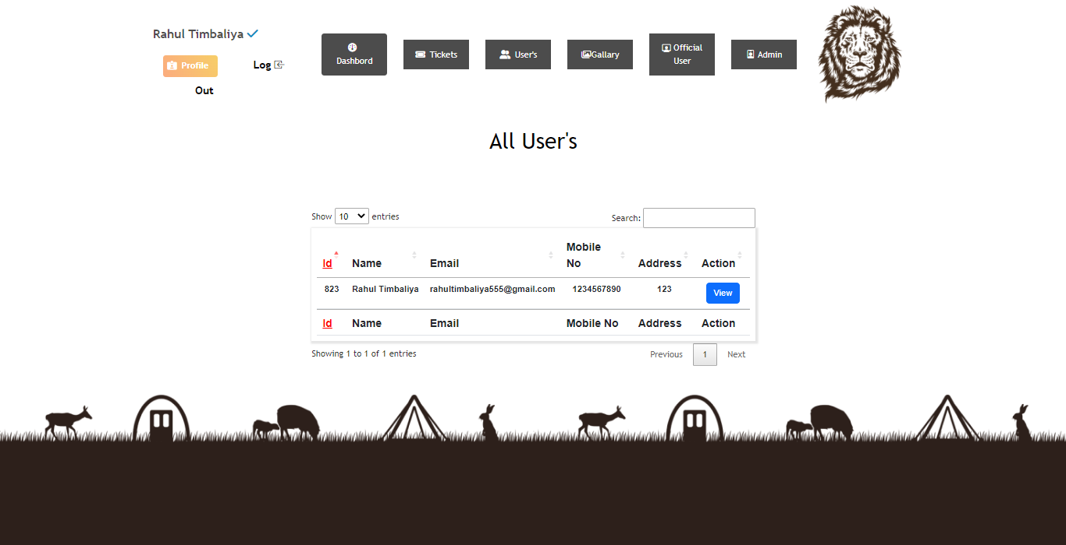

* Add Animal Info:

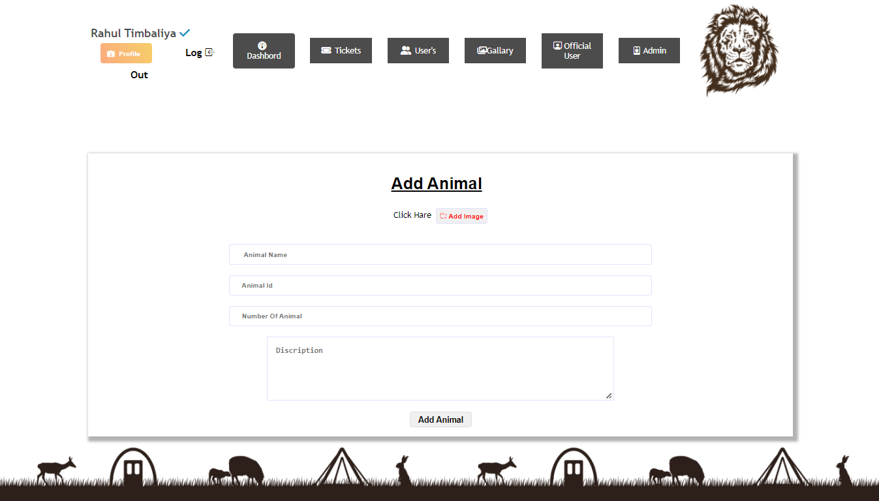

* View Animal Info:

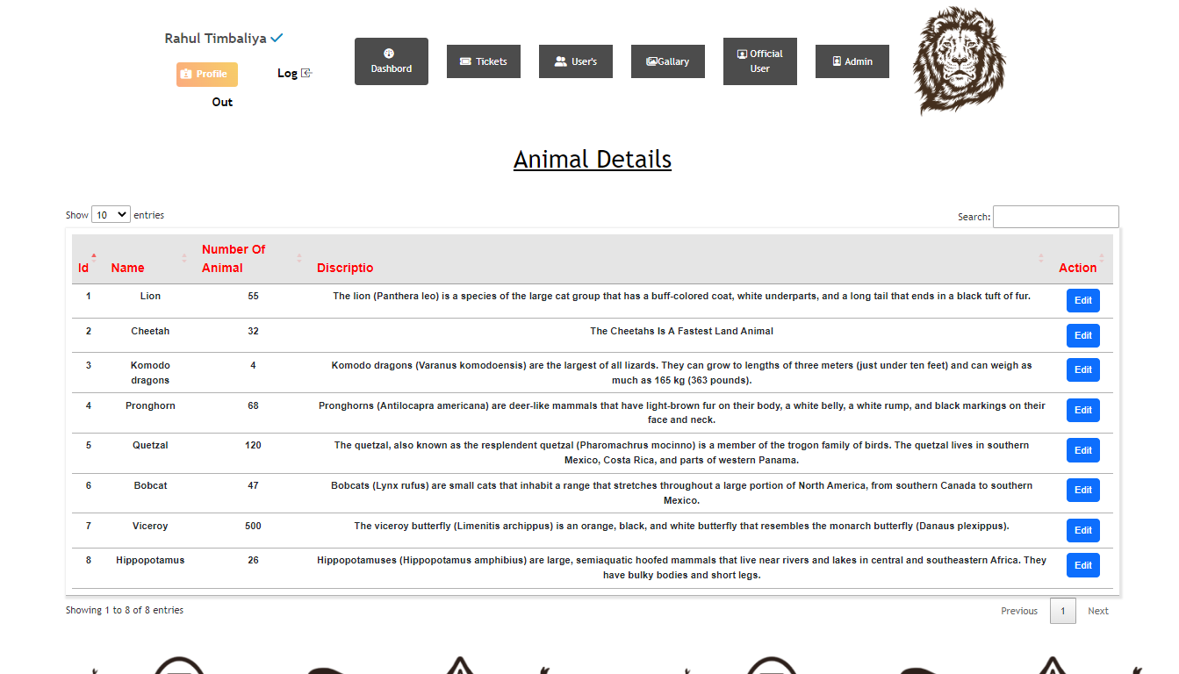

* Add Staff User:

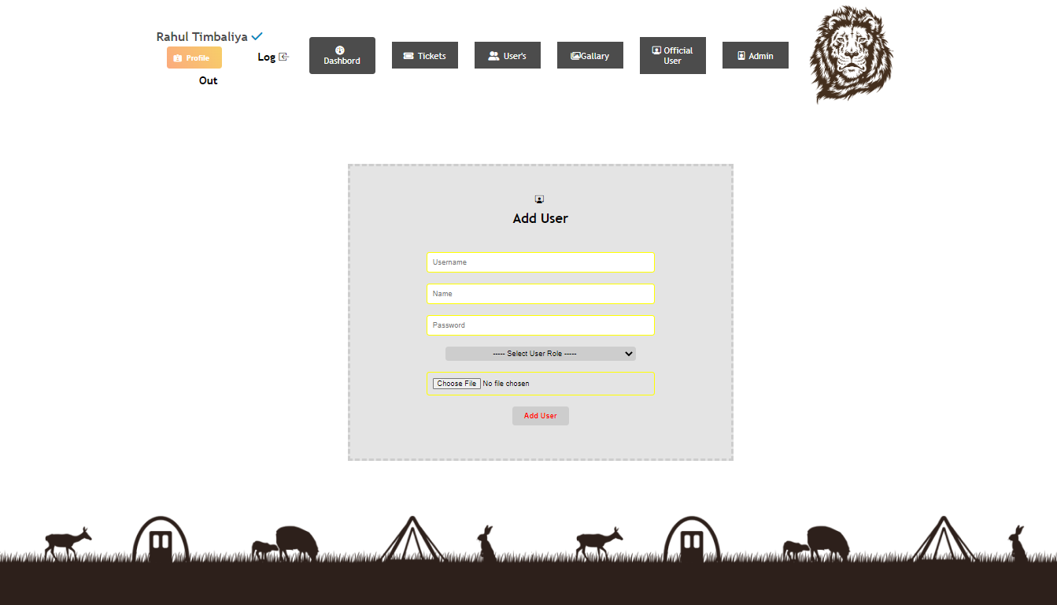

* Add Staff User:

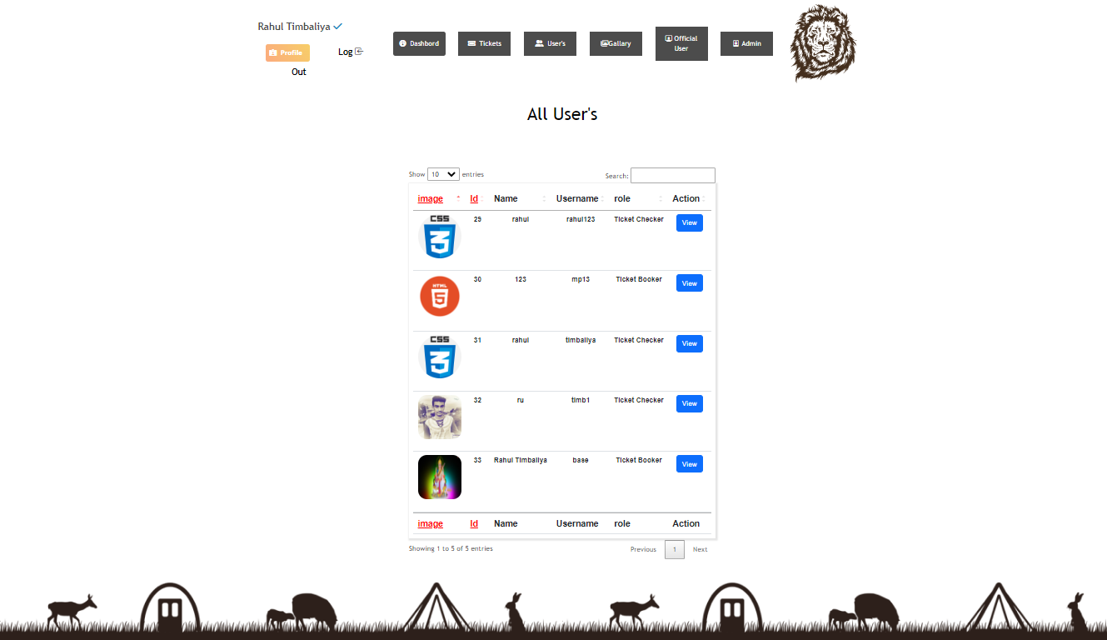

* Add Staff User:

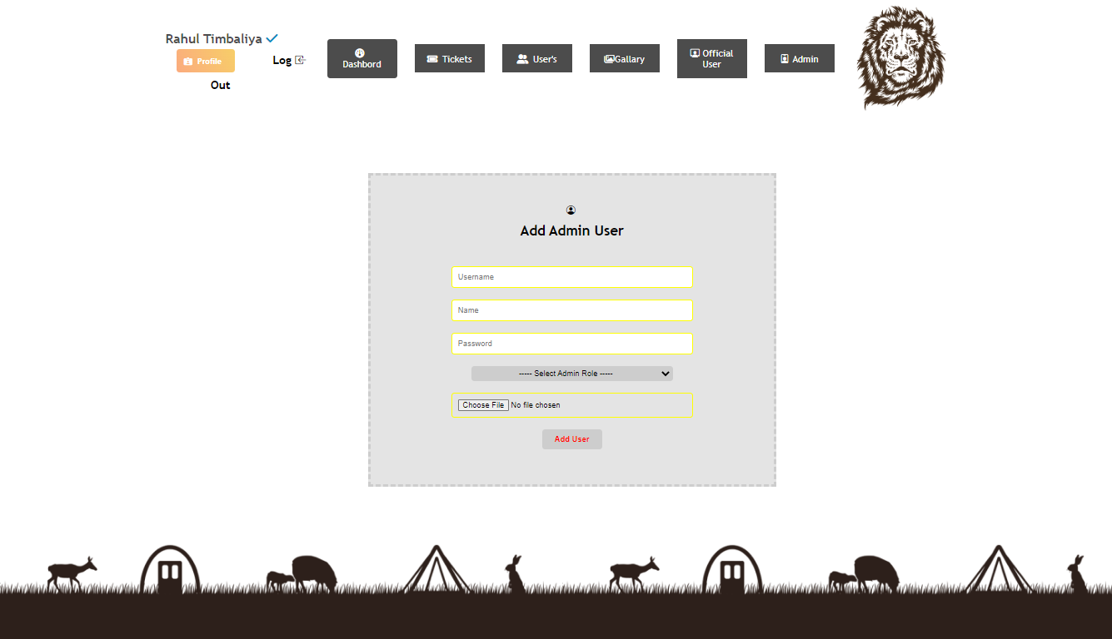

* Add Staff User:

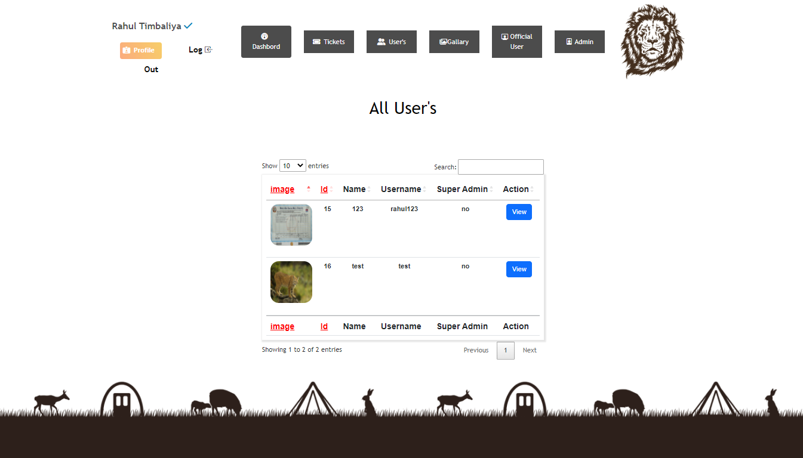

6

**Coding**

7

**Testing**

**(Manual,Test Case And Test dAta)**

**7.1 Manual Testing**

**7.2 Test Case**

**Testing**

Testing is the process of evaluating a system or application, to check whether the application meets all requirements of the client and to detect the errors.

Generally testing can be classified into static testing and dynamic testing.

Again Dynamic Testing is classified into two types: Structural Testing (or) white box, Functional Testing (or) Black Box testing.

**Static Testing**

Verification activities fall into the category of Static Testing. Static testing refers to testing something that’s not running. It is examining and reviewing it. i.e., to check whether the work done meets the standards of the organization. Reviews, Inspections and Walk-through are static testing methodologies.

Example: The specification is a document and not an executing program. When we read it to find out the issues, it is considered as static testing.

**Dynamic Testing**

Dynamic Testing involves working with the software, giving input values and checking if the output is as expected. These are the Validation activities. Unit Tests, Integration Tests, System Tests and Acceptance Tests are few of the Dynamic Testing methodologies.

Techniques used are determined by type of testing that must be conducted.

* Functional ("black box") testing.
* Structural (usually called "white box") testing.

Black box testing involves looking at the specifications and does not require examining the code of a program. Tests that examine the observable behavior of software as evidenced by its outputs without referencing to internal functions is black box testing. It is not based on any knowledge of internal design or code and tests are based on requirements and functionality. Nowadays there are automatic code generation tools and code re-use becomes more prevalent, analysis of source code itself becomes less important and functional tests become more important.

Black box testing is easy as it is based on system’s response for a given user’s input. If we know the business functionality of the product, we can do black box testing. On the other hand, white box testing requires programming knowledge to know the internals of the code. Also it is time consuming. So only a developer can become a white box tester\

**Black-Box** tests are used to demonstrate that:

* Software functions are operational.
* Input is properly accepted.
* Output is correctly produced.
* Integrity of external information (database) is maintained.

**White-Box** tests can be designed only after a component-level design (or source code) exists. The logical details of the program must be available. The status of the program is examined at various points to determine if the expected status corresponds with the actual status.

Internal program logic is tested using ‘White Box’ test case design techniques.

Using White-Box testing methods we can derive test cases that:

* Guarantee that all independent paths within a module have been exercised at least once.
* Execute all loops at their boundaries and within their operational bounds.
* Exercise internal data structures to ensure their validity.

6

**Limitations and Future**

**Enhancement**

* **Limitation :**
* Online payment is not available.
* Mandatory sign-up needed for the Ticket Book. But User Can Visit The Site With Out Sign-in Or Sign-Up.
* Only read module for viewer.
* Different rights for actors.
* **Future Enhancement :**
* Payment method will be available.
* New customization in website.
* Add New Services
* Some UI Changes
* More modules will be updated.
* Bug fixes and performance.
* More attractive.

7

Bibliography

* **Book Used :**
* Software Engineering – R.S.Pressman
* **Reference Sites:**

<https://www.tutorialspoint.com/php/>

https://www. stackoverflow.com/

https://www. getbootstrap.com/

[htttp://www.youtube.com](http://www.youtube.com)/

[htttp://www.jquery.com](http://www.youtube.com)/